# Submit Page

* Horizontal orientation

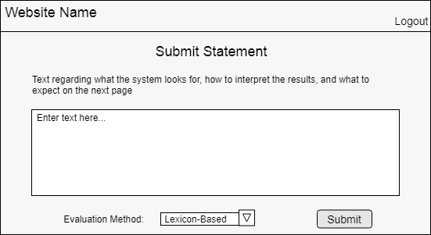

# Results Page

* Remove text box from the “Submit” page
  + Move to a separate “About” page
  + Put in a tooltip (the question mark)
* Horizontal orientation
* Keep submitted text present

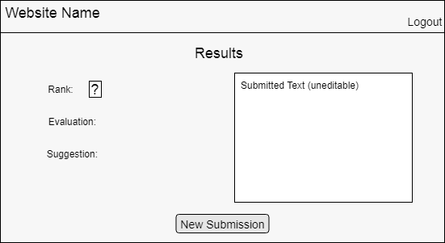

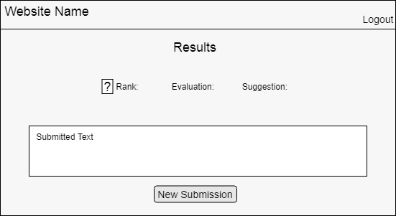

# Lexicon (and Accounts) Management Pages

* Entry box shouldn’t say “New Word” since is edit or add
* Table of words/accounts should be on different page, etc. so the whole thing doesn’t load every time
* New page or tab to view table of stored words/accounts
* Tab to view lexicon/accounts
  + Divide tab view
    - Multiple tabs for categorized data
    - Load X many at a time, load more as needed
  + Click on element to put the details on the left
  + Searching a word finds and highlights it on the right

